Name: Lela Parks

Date: Oct 24, 2024

Module 5 Lab Activity – Iterative Programming Submissions

FlowCharts

M5p1.py Flowchart

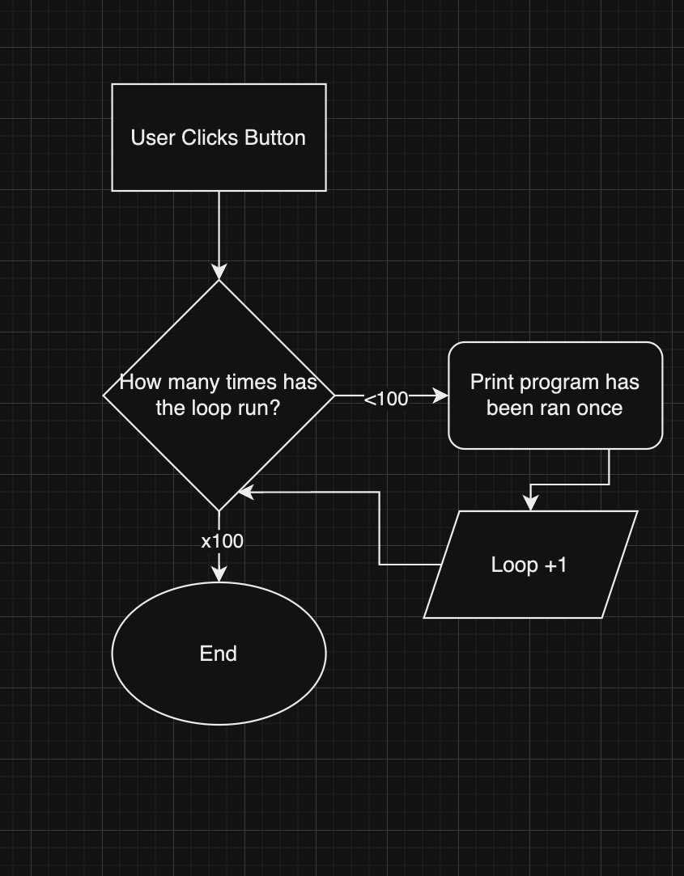

M5p3.py Flowchart